Info Pack
Practical information for your travel

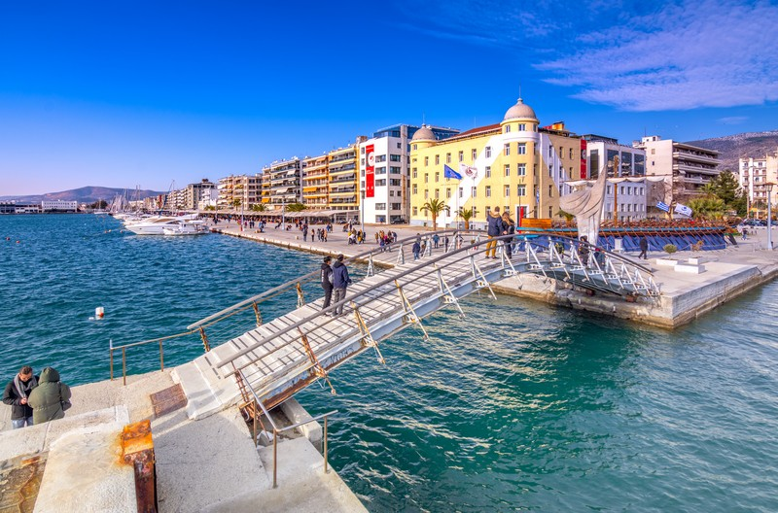

cieaem 72

Table of Contents

The City of Volos 3
Transport from Thessaloniki to Volos 4
Transport from Athens to Volos 6
Contact us 8

The City of Volos

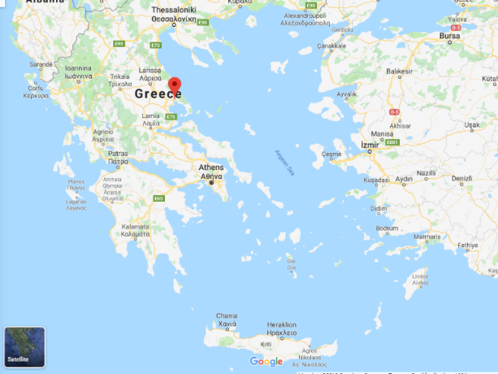
Volos is a coastal port city in the Region of Thessaly situated midway on the Greek mainland, about 330 kilometers north of Athens and 220 kilometers south of Thessaloniki. It is the capital of the Magnesia regional unit. Volos is the only outlet to the sea from Thessaly, the country's largest agricultural region. With a population of 144,449 (2011), it is an important industrial centre, while its port provides a bridge between Europe and Asia.

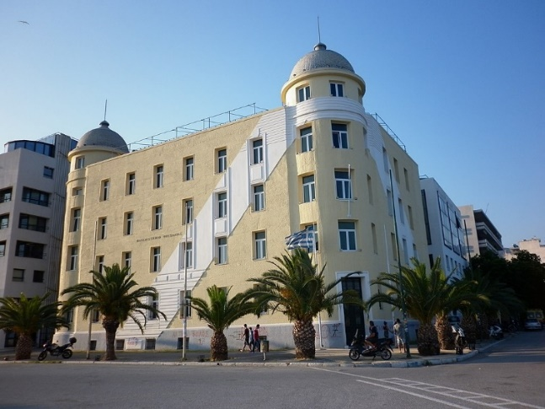
Volos is the newest of the Greek port cities, with a large proportion of modern buildings erected following the catastrophic earthquakes of 1955. It includes the municipal units municipal of Volos, Nea Ionia and Iolkos, as well as smaller suburban communities.

The administrative building of the University of Thessaly at the promenade
The economy of the city is based on manufacturing, trade, services and tourism. Home to the University of Thessaly, the city also offers facilities for conferences, exhibitions and major sporting, cultural and scientific events. Volos participated in the 2004 Olympic Games, and the city has since played host to other athletic events, such as the European Athletic Championships.

Transport from Thessaloniki to Volos

From the Airport to the Bus Station
Flights to Thessaloniki (SKG airport) are available by many airlines from various parts of Europe. During summer months there are also many charter flights. Since you arrive at the airport you can access Volos either by car (as mentioned above) or you can choose between the bus services and the train.
BUS SERVICE: the airport is served by a 24-hour bus service from Thessaloniki Urban Transport Organization. On arrival at Macedonia International Airport you can use the bus line 78 78 (or Line 78N during night hours), route Airport- KTEL/ Central Bus Station, which goes directly to the city center. Tickets can be purchased from the Thessaloniki Urban Transport Organization (OASTH) desk 07:00 – 21:00 (cost 0.80 euros) or from the automatic vendors inside the bus (price 0.90 euros).
TAXI: The cars are easily recognized because they are all blue and white with illuminated sigh marked “TAXI” on top. The cost from the airport to the bus station is estimated to be approximately 25 to 30 euros.
TRAIN SERVICE: You can use bus Line 78 (or Line 78N during night hours), route Airport- KTEL/ Central Bus Station, which goes directly to the city center but you stop at “New Railway Station”.
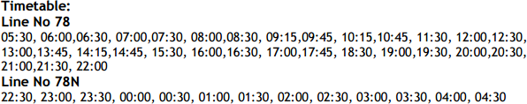

The estimated time that you reach the bus station is 40-55 minutes and the train station 35-50 minutes, depending on city traffic.
Reaching Volos by bus
The bus timetable from Thessaloniki to Volos is available on:
http://ktelvolou.gr/en/routes/map/&map=greece.
Online booking is also available and can be found on: http://ktelvolou.gr/en/home/.
The bus ticket one way costs 20 euros and the round one (including the return) costs 35 euros (as long as the return is within a month). The trip duration is about 3 ^{1/2} hours long.

Reaching Volos by train
The necessary information including the itinerary is available on: https://tickets.trainose.gr/dromologia/.
You should be aware that from Thessaloniki, you firstly reach Larisa where you change train and then head to the city of Volos. The one-way ticket costs 17.60 euros while the round one 28.20. The trip is estimated to be approximately 2 hours long to Larisa and then about one more hour to reach Volos.
[PLEASE ALWAYS CONSULT THE WEBSITE http://www.trainose.gr/en/ TO AVOID UNPLEASANT CHANGES IN THE SCHEDULED ROUTES]

Transport from Athens to Volos

The Athens Eleftherios Venizelos International Airport https://www.aia.gr/traveler/ is located 27 km east of the city of Athens. A large number of European and International carriers fly direct into Athens. The airport has excellent public transit connections to the city.
From the airport you may use:
  - Metro service that will cost you €10
  - Bus service that will cost you €6
  - Taxi that may cost you up to €35 during the day and €50 during the night. The cars are easily recognized because they are all yellow with illuminated sign marked "TAXI" on top.
There are two alternative ways to go from Athens to Volos:
By intercity train: From the Athens airport, using metro or taxi (not bus), you should get off at “St. Larissis” (on the red metro line) and get a train ticket to Volos. You will need to change over at the city of Larissa with the same ticket. For more information on the train service: tickets.trainose.gr/dromologia.
By intercity bus: From the Athens airport, using bus X93 or taxi (not metro), you should get off at “St. Ypera/konLeof. Liosion” and get a direct ticket to Volos. The bus station you have to get off is: LIOSION BUS STATION, For more information:
https://www.athensairportbus.com/en/timetable/x93airporttokifisos.html
For general information about public transportation in Athens:
https://www.thisisathens.org/getting-around/public-transportation-metro-bus-tram
Accommodation

We suggest a number of hotels based on the location, the ease of transportation and the amenities.
- Volos Palace, also available on http://www.booking.com/hotel/gr/volos-palace.en- gb.html, is located close to the city center and to Univerisity. You can walk and reach your destination within 15 minutes. The hotel is available on: https://www.volospalace.gr/en
- Domotel Xenia, is one of the best and more elegant hotels in the city providing luxurious amenities. The hotel is located outside the city center, you can walk and reach your destination within 10 minutes and is available on: https://domotel.gr/xenia-volos/
- Hotel Alexandros, is located near the city center of Volos with an amazing view of the port, and it is of low cost (and less nice inside). You can walk and reach your destination within 5 minutes. For further information, you can visit the hotels’ website on: https://hotelalexandros.webnode.com/
- Aegli hotel, is located near the city center of Volos with an amazing view of the port. For further information. You can walk and reach your destination within 5 minutes. The hotel is available on: https://www.aegli.gr/
- Park hotel, is the nearest to the University, less than 3minutes walking. Ask a room with see view. The hotel is available on: https://amhotels.gr
You may find all of them on booking.com, tripadvisor etc.

Contact us

University of Thessaly (our faculty) is located at argonafton & fiellinon 1 (Αργοναυτών και Φιλελλήνων 1)

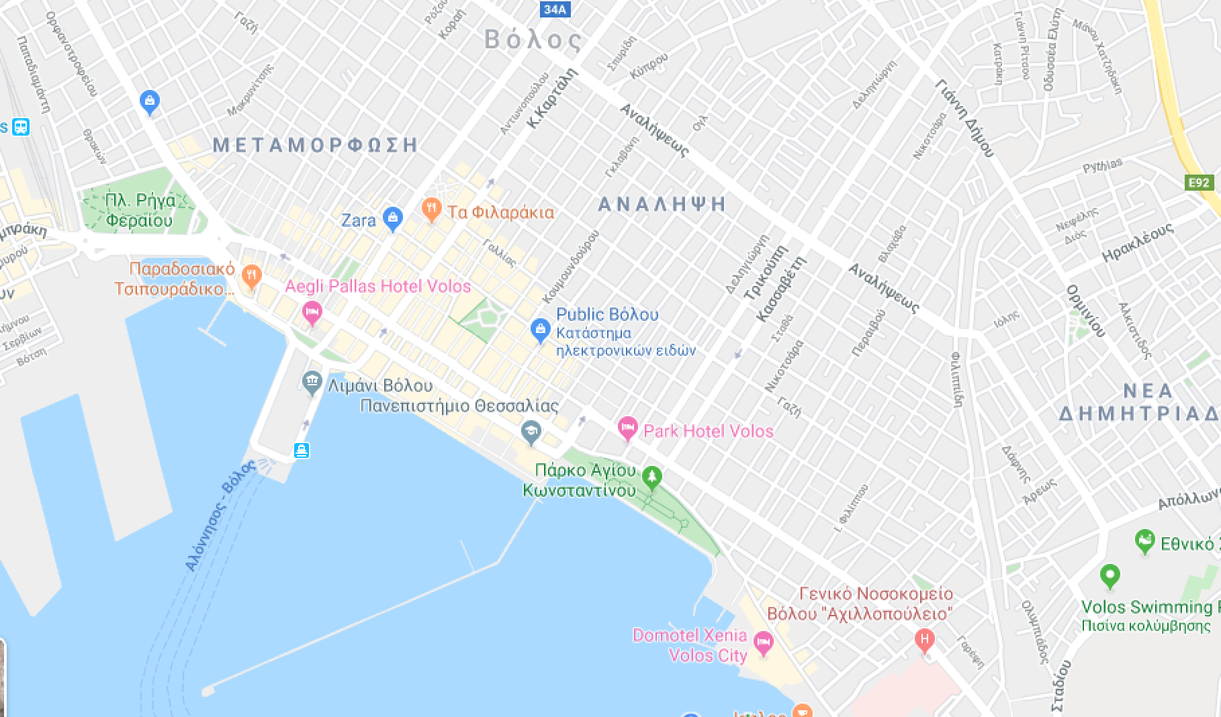

Charoula Stathopoulou  hastath@uth.gr  tel: (+ 30) 6973201279 | Vaso Chrysikou  Email: vchrysikou@gmail.com  tel: (+ 30) 6948409948

